**Cuizine:**

Haleem

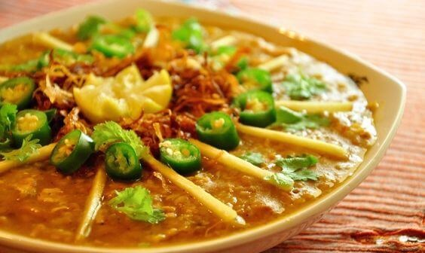

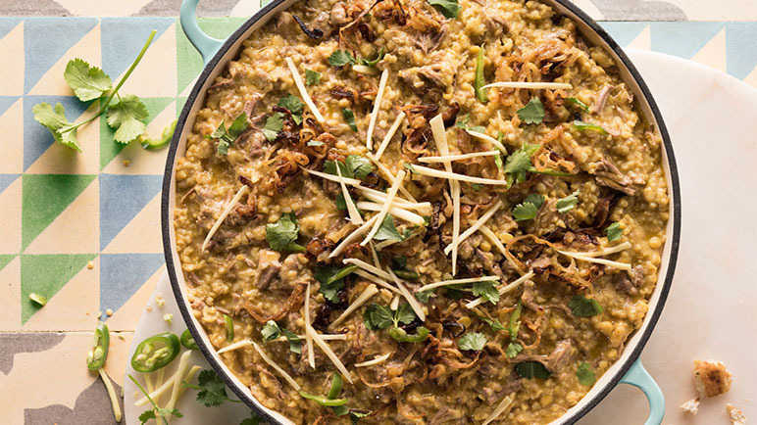

**Haleem** is a stew popular in the Middle East, Central Asia, and the Indian subcontinent. Although the dish varies from region to region, it always includes wheat or barley, and sometimes meat and/or lentils. Popular variations include keşkek in Turkey, Iran, Afghanistan, Tajikistan, Uzbekistan, Azerbaijan and northern Iraq; Hareesa in the Arab world and Armenia; Halim in Bangladesh and West Bengal; Khichra in Pakistan and India. Americans also have a similar dish called Farina. Haleem is made of wheat, barley, meat (usually minced beef or mutton (goat meat or Lamb and mutton) or chicken), lentils and spices, sometimes rice is also used.